Judge Assigning System: gymjas.com
Purpose: To provide clear guidelines for Judges when using the Judge Assigning System. The JAS is a nationwide resource for access and assigning of meet officials in an effort to streamline the assigning process.

Judges:
This is where you, as meet officials, will enter your contact information, your credentials, availability for the coming season, and accept or decline AND submit contracts for assigned competitions. This is your direct line of communication with the meet assigners in your state as well as assigners from other states. It is always appropriate to email and/or call your assigner or SJD if you have any questions, concerns, or changes should you have difficulty navigating through the system. The JAS will be the primary resource assigners will utilize when making meet assignments. It is to your benefit to keep this information updated regularly whenever changes occur.

This document has been created as a resource to help you as you work through the JAS for the upcoming season. Please keep this available when using the JAS system. It will also be available on the KS NAWGJ website, at ksnawgj.org.

General information:
Initial access to the JAS must be initiated by the SJD. Most commonly, judges are added once they pass an exam by the USA Gymnastics professional number. If the judge does not have a USA Gymnastics professional number, they may be added with their AAU number or any number unique to that judge. This number can be changed once a USA Gymnastics professional number is obtained. Other information which can only be changed by the SJD includes a rating change or to archive a judge who no longer wishes to maintain their active status. In the case of a change in rating, please notify the SJD as soon as exam results have been received. While this information can be checked by the SJD, the SJD receives no information regarding exam participation or exam results from USA Gymnastics. Therefore, it is the primary responsibility of each judge to communicate any changes in rating after testing. This will ensure accurate ratings are available to assigners and appropriately rated judges are assigned to meets.

Below you will find instructions with screen shots to demonstrate how to maneuver through the JAS. The system is designed to be relatively intuitive, but for a first -time user it can be confusing. As stated above, this is simply a resource to help guide you through the process. Do not hesitate to contact your assigner or SJD with help if something is unclear.

INITIAL ACCESS:
The first time you access the JAS, you will need to register.
- Go to gymjas.com and select the state where you are registered with USA Gymnastics or where you reside.
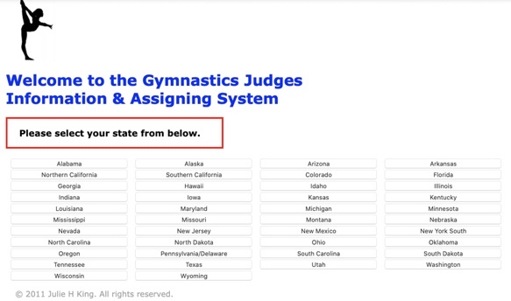
- Select JUDGE ASSIGNING SYSTEM
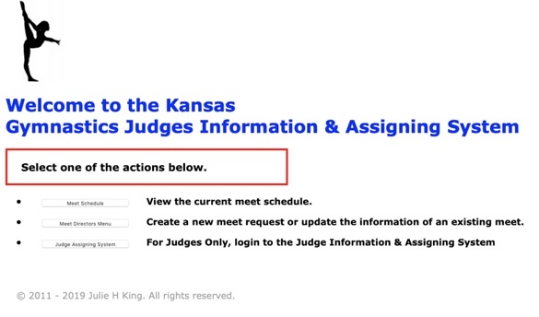
- Select REGISTER HERE at the top of the page.
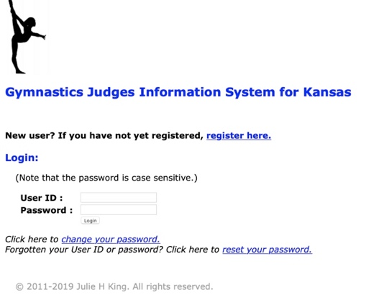
- Complete the form using either your USA Gymnastics professional number (preferably), your AAU number, or the unique PIN created and communicated to you by your SJD. Create your own username and password and submit the email address you prefer for gymnastics related communication. Once complete, select REGISTER.

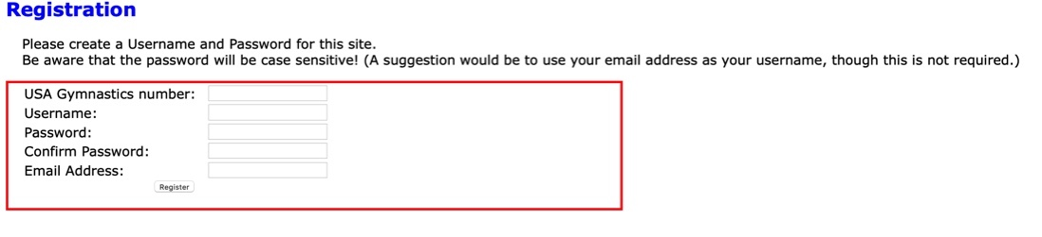
- This will take you to the home screen.
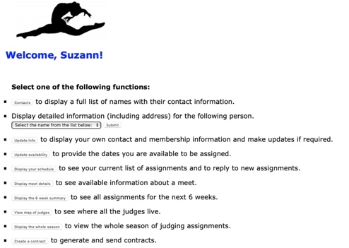
- In the future, you will follow the first 2 steps and the login with your username and password to get to the home page.

CONTACTS:
This area includes an alphabetical listing of the judges in your state, their contact information, and their rating(s). It is purely informational and is updated by each individual judge.

DETAILED INFORMATION:
This area is also informational. From this screen you can select 1 specific judge to obtain contact information, rating(s), affiliation, mailing address, and emergency contact information.

UPDATE INFORMATION:
It is important that you complete this section the first time you access the JAS and update it regularly. It is imperative this information is current for the assigner to make appropriate assignments and initiate contracts. Credentials such as USA Gymnastics membership, Safety Certification, Background Check, Safe Sport, and CPEs (continuing professional education credits) must be current to be assigned to a meet. While it is recommended, a current NAWGJ membership is not required for assignment. A current AAU number is required to be assigned to an AAU event. Except for USA Gymnastics professional numbers and ratings, YOU are expected to ensure this information is correct. Should you believe there is a discrepancy in your USA Gymnastics professional number or rating, Contact your SJD as soon as possible.

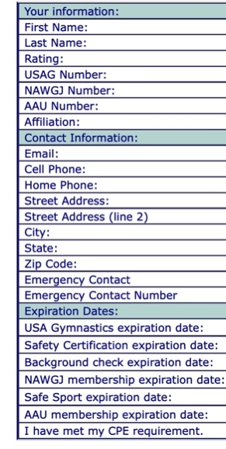
UPDATE AVAILABILITY:
The Update Availability area is where you communicate the dates you are available to judge to the assigner. Simply check the dates you are available to judge and click the submit button at the bottom of the page. Available dates will turn green once you have indicated you are available. It is expected these dates may change over time - you may have a preference to travel or not, or may not be available the entire weekend. All of this is perfectly acceptable, but it is imperative you communicate your change in availability as soon as possible.
Once the assigner has you tentatively assigned to a meet, you may not be able to make a change in the Update Availability section. This is referred to as a meet being in “draft mode”. It is essentially a white board or preliminary mapping stage only visible to the assigner and SJD where judges are tentatively assigned to ensure meets are scheduled appropriately according to meet director requests, locality, numbers of officials, and ratings. In this instance, if you are no longer available and cannot make the change yourself, you should call and/or email the assigner and/or SJD to communicate the change. Assignments are not official until a contract has been initiated by the assigner or SJD. Remember that being available does not ensure assignment.

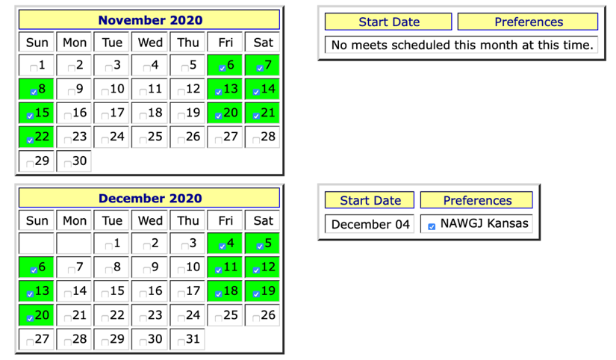

DISPLAY YOUR SCHEDULE:
In this area you will be able to review your own judging schedule for the current calendar year. It will display upcoming meet assignments, their dates, names, event assignments, and contract status and an archive of meets you have already judged. Of note, you will find the number of in-state meet contracts you declined over the past year. This information is purely informational, but can be useful when a judge is being considered for a meet in another state, a state championship competition, or regional or national assignment.

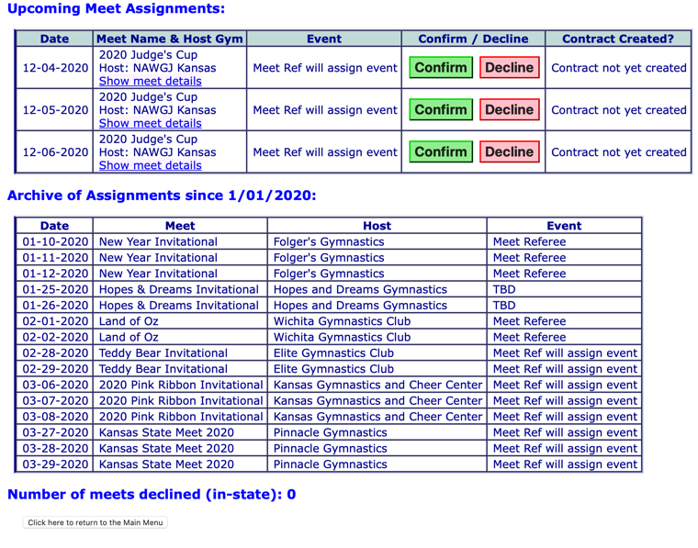

DISPLAY MEET DETAILS:
The Display Meet Details is helpful when the judge would like to access information about which have been submitted into the gymjas system. Initially the meets are listed by date, host gym, name of meet, whether the meet has been accepted for assignment, the type of meet (USAG, AAU, HS, etc.), and all levels for competition.

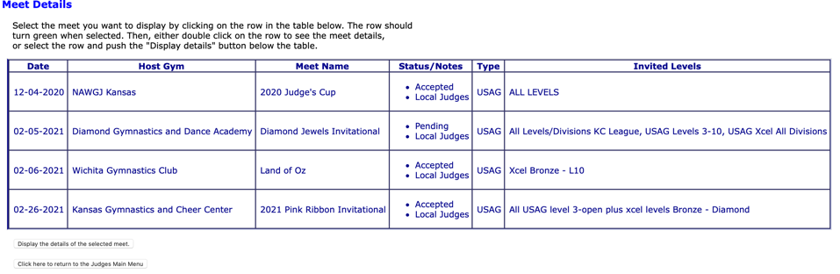

If you would like more detailed information about a specific meet, you can select a meet by simply clicking on it. Information such as meet director, site, format, uniform, and judging panels will be displayed in a clear and concise table. For example, the Land of Oz meet information is detailed below. The meet director may update the information as the event comes closer and they have a better idea of the number and levels of athletes and the format of the event.

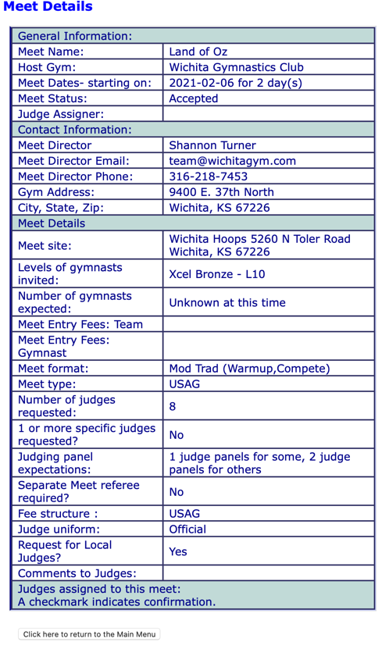

DISPLAY THE 6 WEEK SUMMARY:
In the Display the 6 Week Summary section, a short synopsis of the upcoming meets and the associated assignments will be displayed here. This may help in planning as the season progresses.

VIEW MAP OF JUDGES:
This is a Google Map displaying the primary residence of judges in your state. It is designed to assist assigners in selecting judges in close proximity of the meet site and to assist judges in organizing carpools. Meet directors have the option to select “local judges” when making judging requests in an effort to minimize travel expenses associated with judges for a meet. Meet directors also have the option to request judges from anywhere in the country. It is the assigner’s responsibility to honor those requests to the best of their ability while also ensuring the proper number and rating of officials are assigned.

DISPLAY THE WHOLE SEASON:
Similar to the 6-week summary, a summary of the entire judging season is included in this area. This is a tool to help judges determine their availability for the upcoming season. Again, it includes the date, name of meet, host club, and associated assignments.
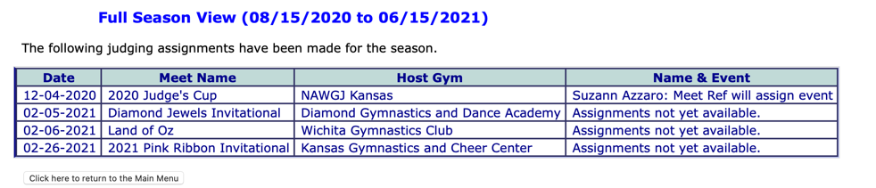

CREATE A CONTRACT:
Create a Contract is essential in the communication of your intent to accept or decline a contract. Once you receive notice that you have been assigned a meet, you must go to the Create a Contract section in gymjas to accept the assignment. If you fail to do so within 2 weeks, a red flag will be indicated on the right- hand side of the meet. This is to draw your attention to the fact that you have a pending assignment. Failure to submit a contract within the 2-week window may result in the meet director assuming you have declined the contract and deciding to replace you with another official. Please check this area often in that there have been situations throughout the country where a notification email has not been generated when the assigner finalizes meet assignments. Gymjas has addressed this issue and does not anticipate this being an issue moving forward, but please be diligent about checking for pending contracts in that errors can occur. Every effort will be made to ensure notification of a pending contract by the assigner and SJD.

Once a contract has been generated, a copy of the contract will be displayed on your screen. In addition, you should receive a confirmation email in your associated email inbox.

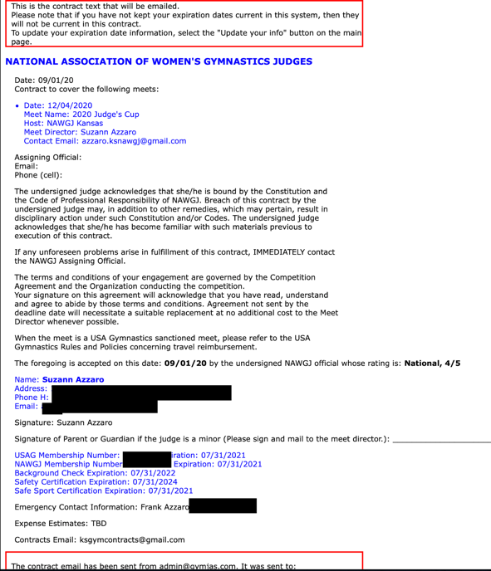

Final confirmation of a created contract will be indicated on the Create a Contract page by each meet in the far right-hand column. Once the contract has been created, there is no further action necessary on your part. A confirmation email will be sent to the meet director and the assigner.

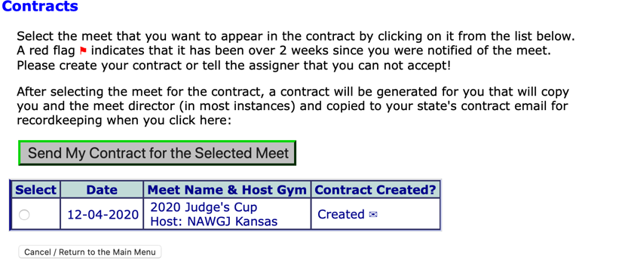

OUT OF STATE, AAU, NGA, AND HIGH SCHOOL EVENTS:
As long as a meet is assigned through gymjas, it will automatically be displayed in the Display Your Schedule tab, whether the meet is in your state or not. If you accept meets not assigned through gymjas, they can be documented in gymjas and you will be covered by NAWGJ insurance if you personally submit the meet to the assigner or SJD. This would include meets associated with other organizations such as AAU, the National Gymnastics Association, City and League meets, and high school meets. Neither the SJD nor the assigner are privy to this information, so it is the responsibility of each individual judge to ensure your meets are submitted to your SJD or assigner.

SUMMARY:
Hopefully you find this document helpful in the coming months. Gymjas is a tool designed to streamline the process of assigning by keeping the wishes of the meet directors and the best interests of the judges in one centralized area. This can only work when all parties involved clearly communicate and update information as it comes available. Please let you assigner or SJD know if you have any questions or concerns as you navigate through the coming competition season.

